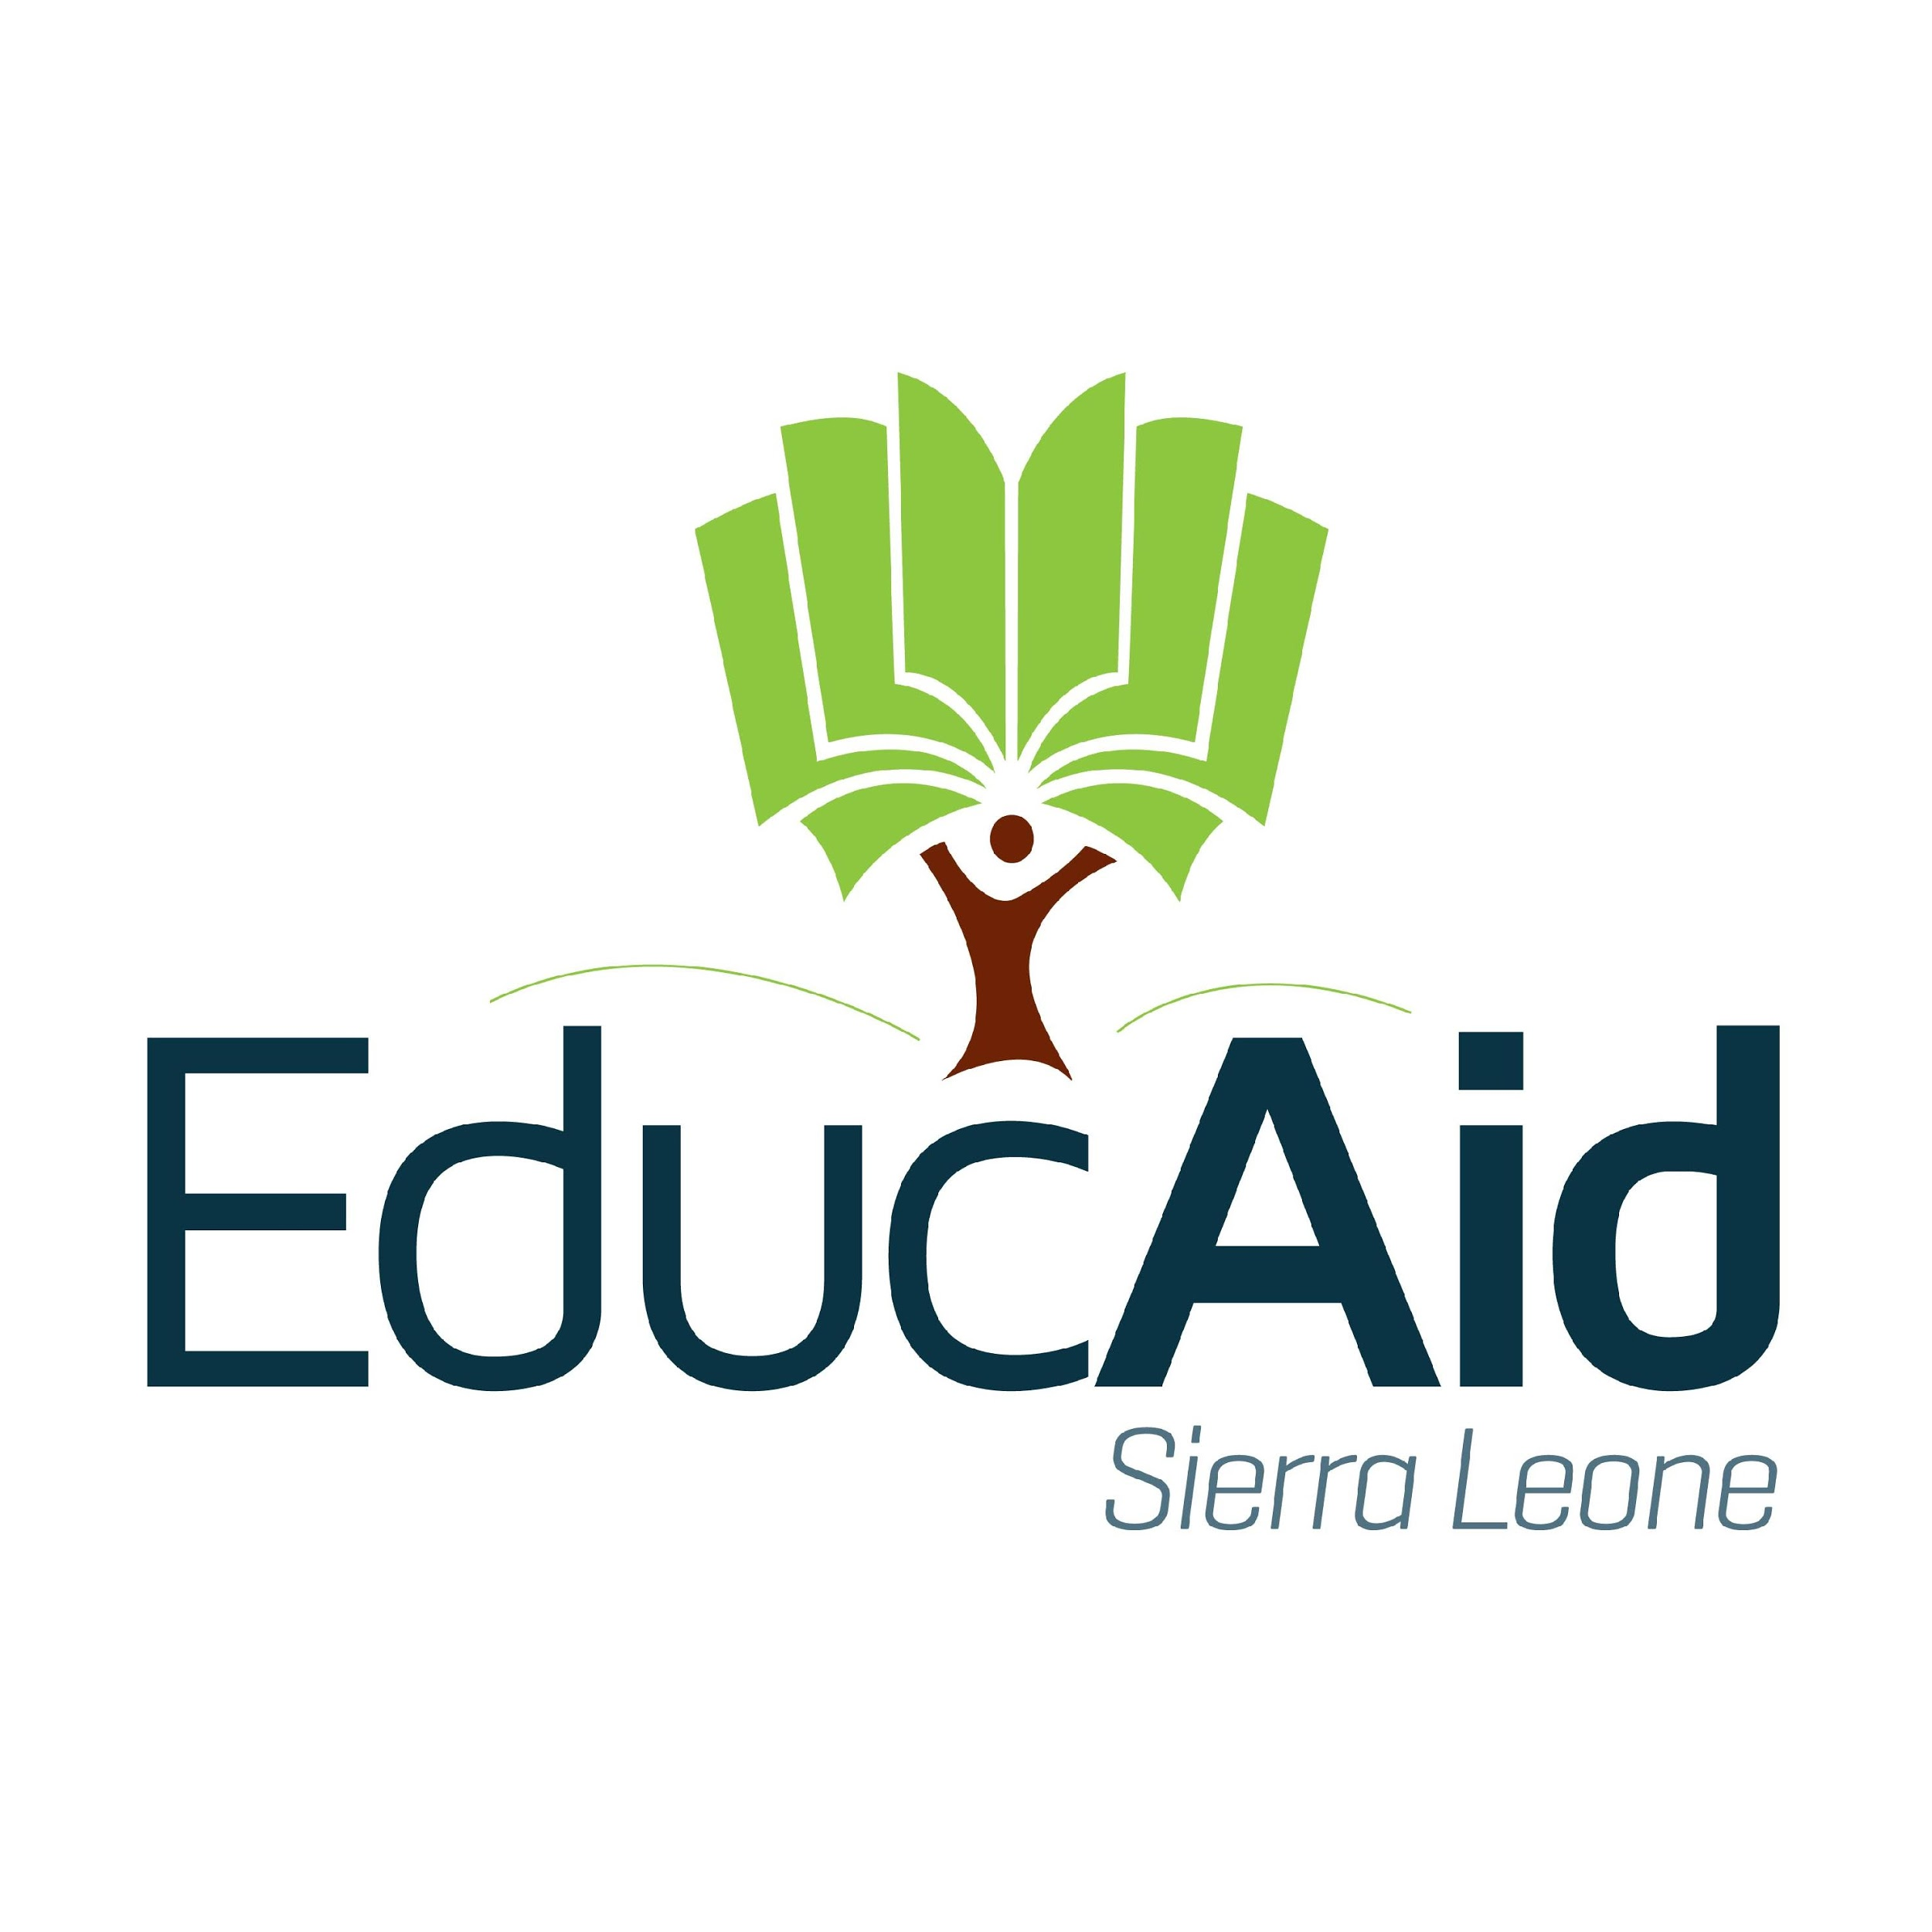

Volunteering in Sierra Leone (BAM Edition)
This guide is designed to help you think through the practicalities and realities of volunteering with EducAid in Sierra Leone.

Reality Check
Volunteering with EducAid can be an extremely rewarding experience, with benefits to both the volunteer and the charity. The students and staff are always keen to share their experience and to work with inquisitive and engaging individuals. There are some important factors that must be considered prior to making a commitment to volunteer with EducAid, which we have outlined below:

A place of learning
Staff that are working in our schools have knowledge, skills and experience that have been developed during their time in EducAid and demonstrate a high degree of dedication to their work. It is important that you are prepared to learn from them as much as you are ready to teach them - they will help you, but it would be wrong to volunteer thinking that you have all the answers to problems that you may have not considered.
Your behaviour and relationship with our staff and students is extremely important. It is vital that you are ready to accept the working practices of EducAid; everyone will try to help, but you must be willing to accept advice and to act upon it. After all, the teachers and students achieve excellent results, whilst the back office staff run a tight ship to keep things running – of course, you may be able to help EducAid be even better, but it is important to learn as well as to teach.

Basic, but adequate
The conditions in Sierra Leone can be difficult: little in the way of teaching and learning resources, poor internet and IT provisions, limited access to power, with only basic food and accommodation provided for volunteers. The weather can be hot, and this, together with the heavy rains during the rainy season, can make life more tiring than the same tasks in a more equable climate.
EducAid will provide you with food, but it will be very basic. Meals consist of rice and are seasoned with cassava leaves or spices. There is typically fish in the dishes but it is spread thin so it’s unlikely that you’ll get more than a few bones. The meals can be repetitive and not particularly filling, but they are adequate. You will be able to get hold of a piece of fried chicken and bread, boiled egg and mayonnaise or something similar within walking distance of most of our school sites.
We are committed to keeping our overhead costs low, and we do not believe that those visiting should expect significantly more than our students, so we do not invest in additional comforts for volunteers. Privacy and security are our top priority when it comes to volunteers, but please do not expect comforts you might have at home.

How much?
It’s important to recognise that EducAid takes a lot of time to organise and manage your volunteering experience; this comes at a cost. Whilst we do not want to be the kind of organisation that charges volunteers for their experience, we do insist that volunteers cover all of their costs. A rough guideline on costs can be found below:
- Flights: -£650  - Visa: ~£105  - Travel Insurance: ~£25  - DBS Check: -£15 | - Weekly Subsistence: ~£25  - SL Airport Transfers: ~£80  - Vaccinations & Malarials: ~£150
 | - Av. 1 Month Trip Cost: ~£1,125
 | - Av. 1 Term Trip Cost: ~£1,325

Be ready
Our intention is not to dissuade anyone from volunteering with EducAid. We want to ensure that all visitors are prepared for their trip so that they can fully engage and enjoy their experience. If you do volunteer with EducAid in Sierra Leone, you will find the work very rewarding and all the EducAidians friendly and helpful.
They may have little or nothing, but what they have they will willingly share.

What is expected
It is important at this stage to have an understanding of what EducAid will expect of you before, during, and after your visit to Sierra Leone.

Behaviour
We expect you to behave professionally, with compassion and respect to everyone you work with and encounter in Sierra Leone. You will be an ambassador for EducAid so please act accordingly.

Funding
We expect volunteers to completely cover the cost of their trip. Whilst it is impossible to fully cost the trip in advance, we expect it to be in the region of £1,200.

Spreading the word
We ask all volunteers to perform no fewer than 3 public speaking events within 6 months of your return to the UK to speak about your trip. This could be at your company or office, your child’s school, your faith institution or at a fundraising dinner organised with your friends or another alternative that you may want to suggest.
We want you to commit to spreading the word about EducAid, and we can support you with materials and information as required.

Administration
We need to protect our staff and students from a governance perspective. We will need you to go through a number of administrative steps, including:
- Purchasing volunteer’s travel insurance and providing us with the policy top sheet.
- Obtaining a DBS Check
- Applying for a Visa in Sierra Leone (via https://www.visitsierraleone.org/online-visa)

Formalities
- Signing a Volunteer contract, stipulating minimum expectations during your trip
- Signing our Code of Conduct to ensure that you understand what constitutes acceptable and unacceptable behaviour and commit to acceptable behaviours

Transportation of goods
We sometimes ask volunteers to be prepared to help us take essential items to Sierra Leone in their luggage as we often have things that are needed in country such as printer cartridges and other materials. We will always show you the items we would like you to bring before you travel if we have things to go to Sierra Leone.

What are the steps to becoming a BAM Lecturer?
First and foremost, your suitability as a BAM Lecturer needs to be assessed by submitting a current CV to EducAid’s BAM Coordinator, Ezekiel Nonie (Ezekiel@educaid.org.uk).
Once you and Ezekiel have decided which module you will present and on what dates, there are a number of steps to take. Below we set out a step-by-step guide for you to follow.

- Read these documents
You’ve already got in touch with us to signal your interest, and this document is one of following 6 documents that the coordinator has sent over to you:
  - Volunteer Eligibility Declaration
  - ‘Volunteering in Sierra Leone’
  - EducAid Code of Conduct
  - EducAid DBS letter to lecturers
  - DBS Self Declaration Form
  - E-Bulk Guide for Applicants (Guide to DBS Check)

- Paperwork, paperwork, paperwork
Once you have read through all of the documents, please begin your DBS check online and complete and return the Volunteer Eligibility Declaration, DBS Self Declaration form and Code of Conduct. Please reach out to Erin Northey (erin@educaid.org.uk) if you have any questions about any of these.

- DBS Check
Once your DBS check has begun online, you will need to show Erin your identification documents (see checklist in letter and in E-Bulk Guide for Applicants). If you are unable to bring your documents to the EducAid office, you can do a verification at your local post office. Verified copies should then be sent to the EducAid office.

- Get Booking!
Once we’ve received your successful DBS check, and you’ve received the letter of invitation from Ezekiel, you are ready to organise the final parts of your trip:
  - Applying for your Visa
  - Buying flights
  - Purchasing insurance
  - General Info
  - Vaccinations & prevention from bites and stings
  - BAM module preparation and supplies (be sure to check with Ezekiel about how to make sure you have back up slides, etc. available should there be no internet or electricity)

- Pre-visit preparation
Now you’re all booked up, it’s important that you think through these essentials:
- Money
- What to pack
- Transporting items to Sierra Leone
- BAM module materials and plans
- Fundraising before your trip

